FUNCTION PACKAGE:

CREATE OR REPLACE PACKAGE taxes_pkg IS

FUNCTION tax (p_value IN NUMBER) RETURN NUMBER;

END taxes_pkg;

/

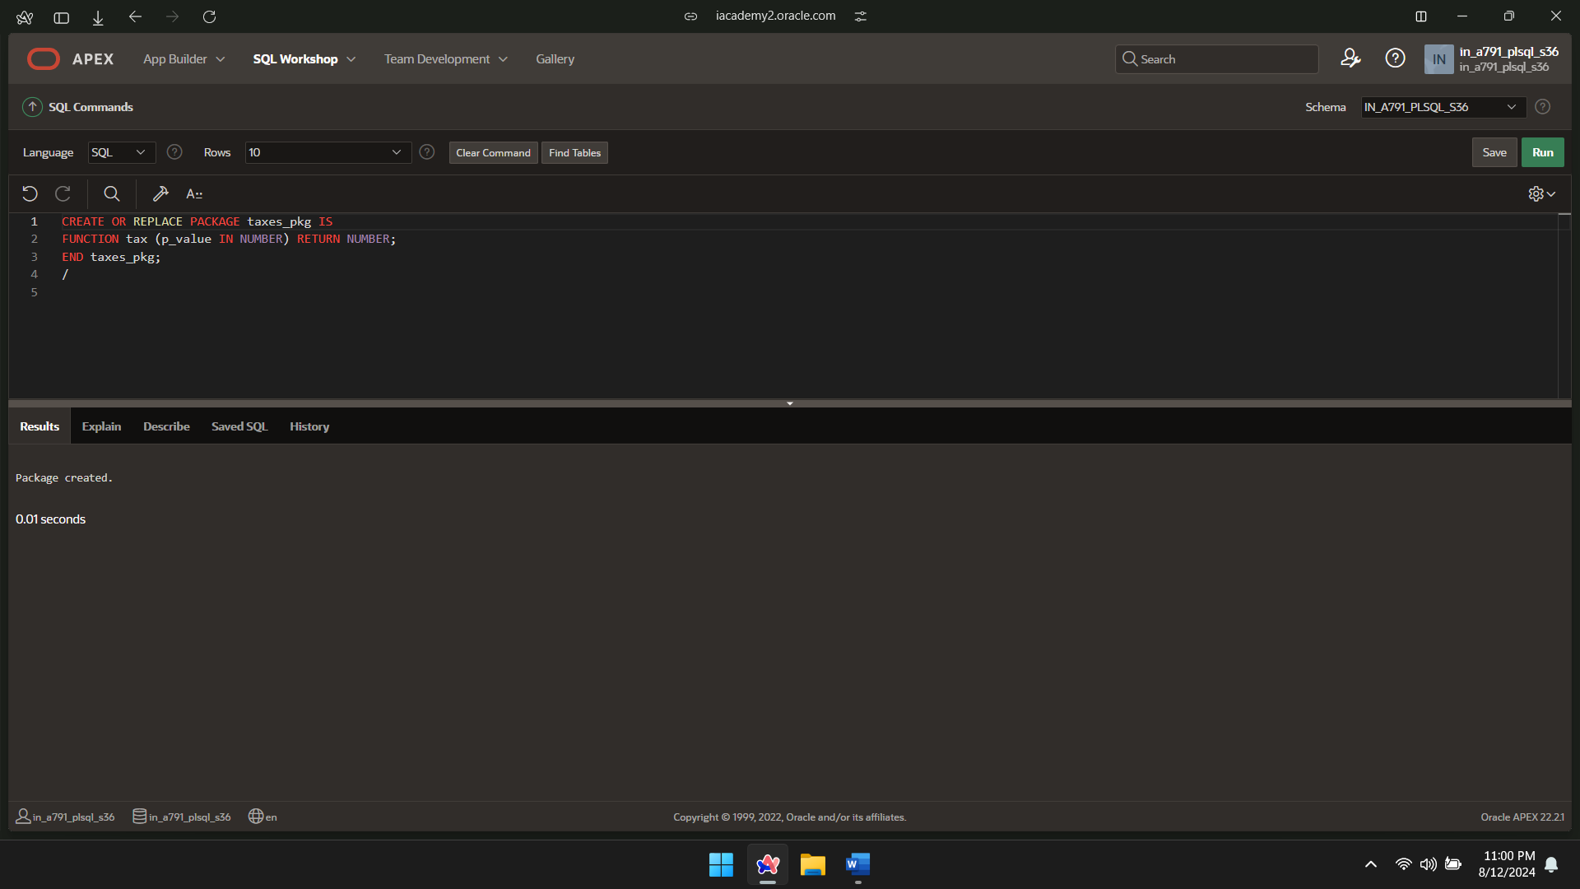

FUNCTION PACKAGE BODY:

CREATE OR REPLACE PACKAGE BODY taxes_pkg IS

FUNCTION tax (p_value IN NUMBER) RETURN NUMBER IS

v_rate NUMBER := 0.08;

BEGIN

RETURN (p_value * v_rate);

END tax;

END taxes_pkg;

/

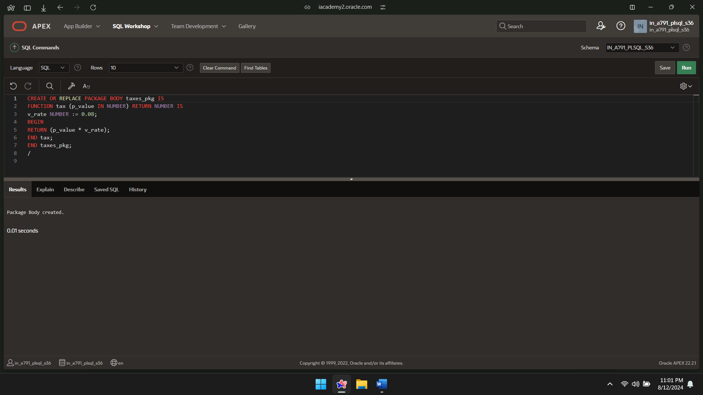

SELECT taxes_pkg.tax(salary), salary, lastname FROM employees;

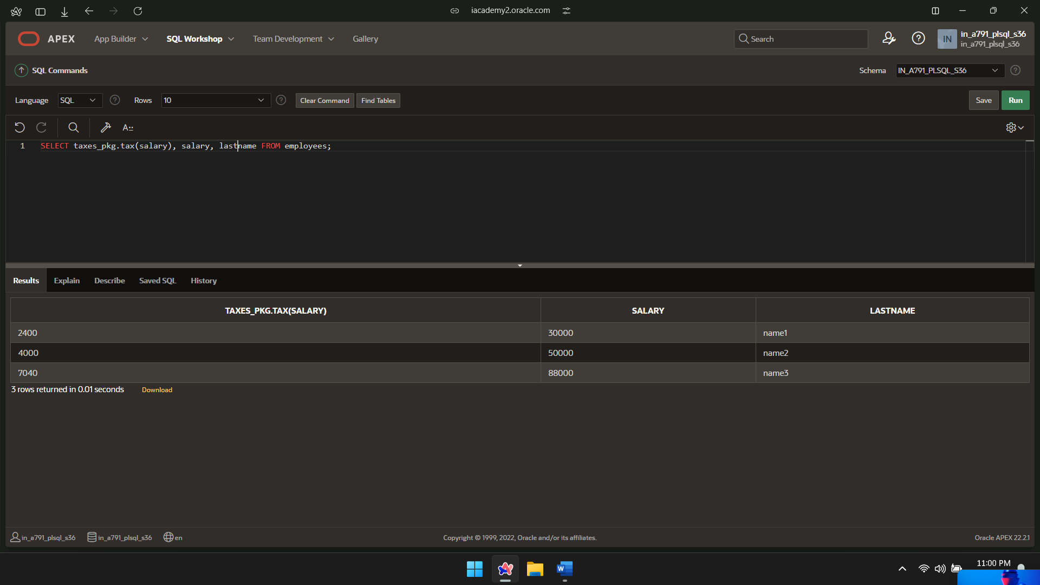

RECORD PACKAGE:

CREATE OR REPLACE PROCEDURE sel_one_emp (

p_emp_id IN employees.empid%TYPE,

p_emprec OUT employees%ROWTYPE

)

IS

BEGIN

SELECT *

INTO p_emprec

FROM employees

WHERE empid = p_emp_id;

EXCEPTION

WHEN NO_DATA_FOUND THEN

RAISE_APPLICATION_ERROR(-20001, 'Unexpected error occurred: ' || SQLERRM);

END sel_one_emp;

/

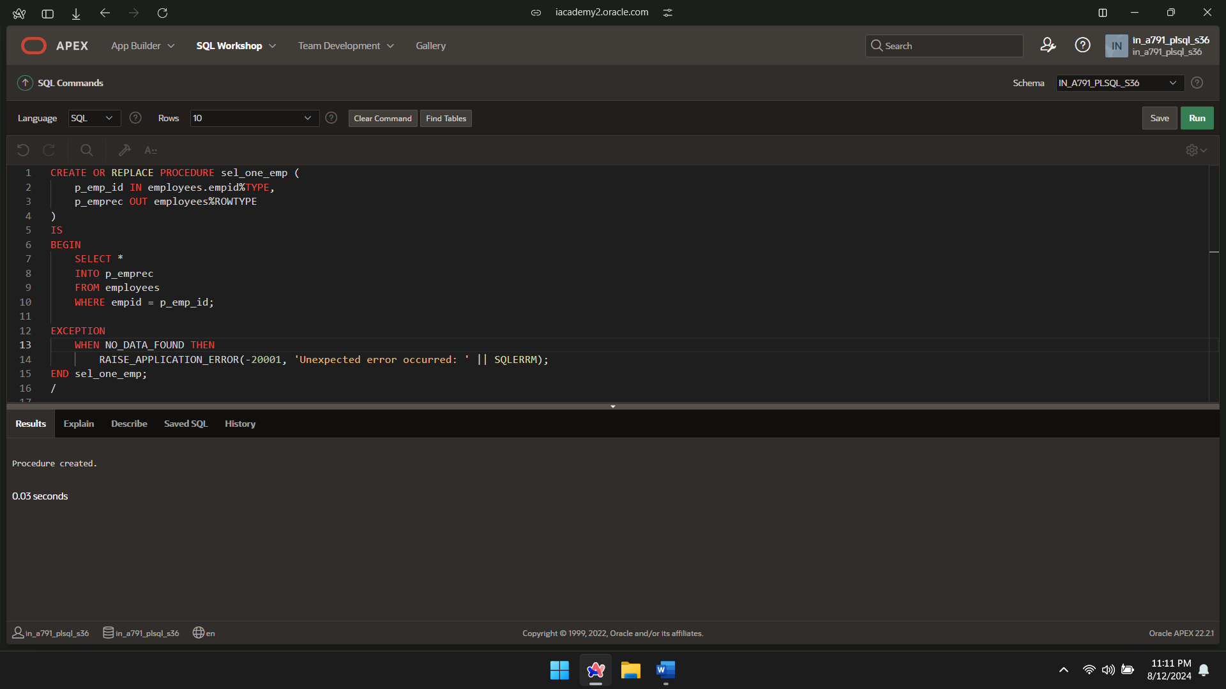

RECORD PACKAGE INVOKE:

DECLARE

v_emprec employees%ROWTYPE;

BEGIN

sel_one_emp(100, v_emprec);

IF v_emprec.empid IS NOT NULL THEN

dbms_output.put_line('Last Name: ' || v_emprec.lastname);

ELSE

dbms_output.put_line('No data found for the given employee ID.');

END IF;

EXCEPTION

WHEN OTHERS THEN

dbms_output.put_line('An unexpected error occurred: ' || SQLERRM);

END;

/

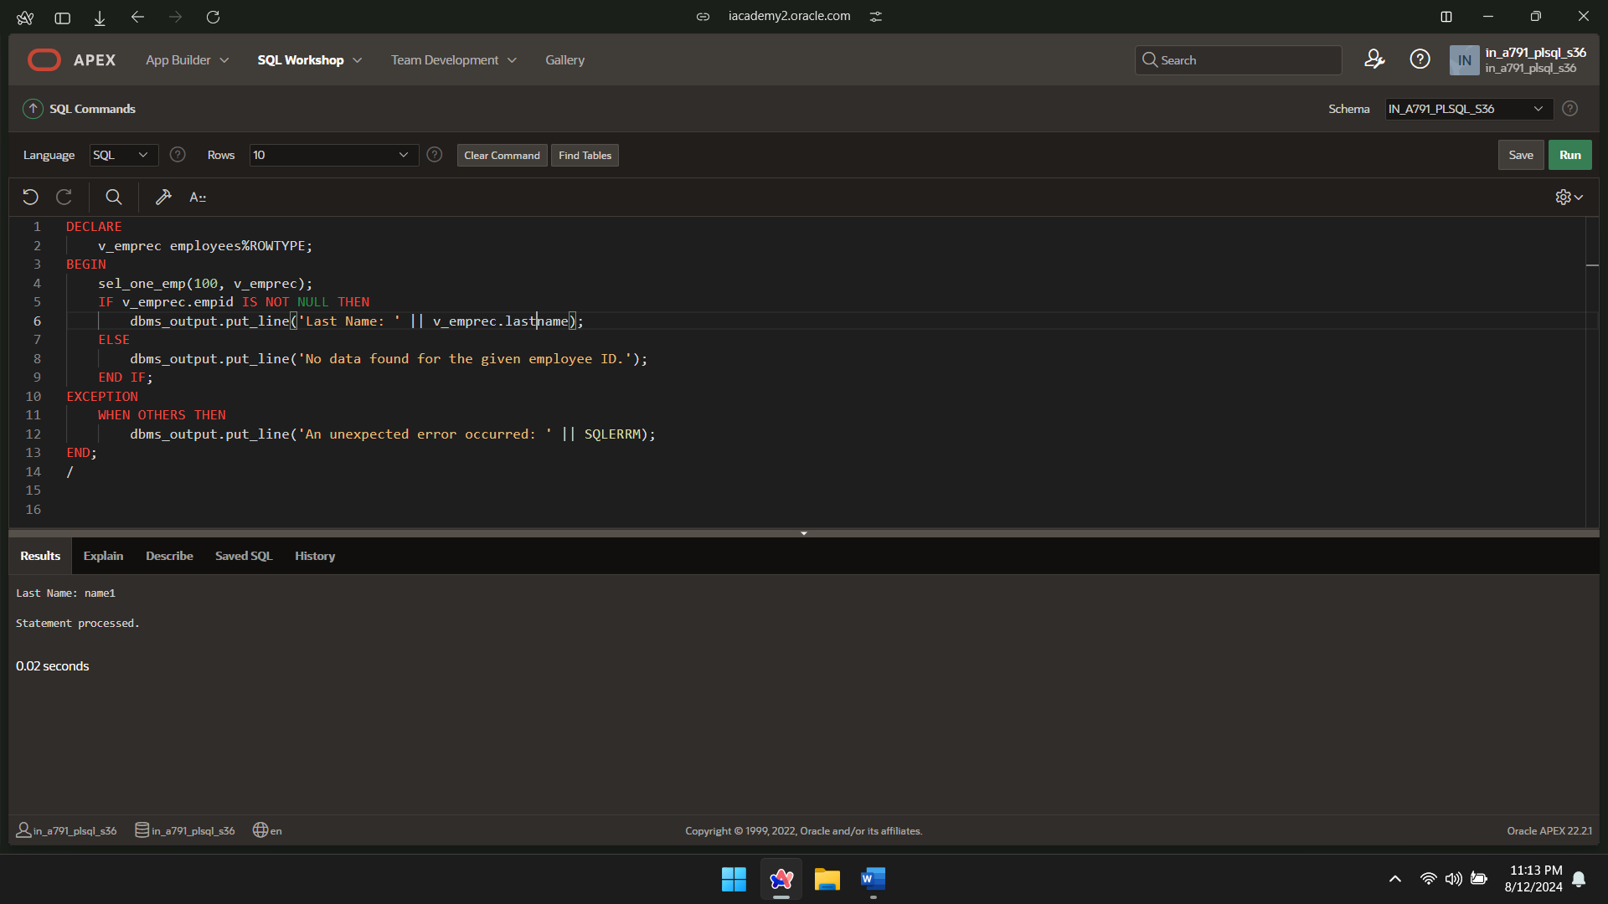

User-Defined Package:

CREATE OR REPLACE PACKAGE emp_dept_pkg

IS

TYPE ed_type IS RECORD (

f_name employees1.firstname%TYPE,

l_name employees1.lastname%TYPE,

d_name departments1.departmentname%TYPE

);

PROCEDURE sel_emp_dept (

p_emp_id IN employees.empid%TYPE,

p_emp_dept_rec OUT ed_type

);

END emp_dept_pkg;

/

